<h1>Github Basics:</h1>

<h2>Setup</h2>

<ul>
- <li>CD into directory</li>

- <li>run ‘git init’ to create repository</li>
- <li>Check status of git repo with ‘git status’</li>
- <li>Add files to staging areas with ‘git add <filename> <filename> ….’</li>
- <li>Check difference between files in WD & SA with ‘git diff <filename>’</li>
- <li>Add files to Repo with ‘git commit -m "Complete first line of dialogue"’</li>

- <li>View all previous commits ‘git log’</li>
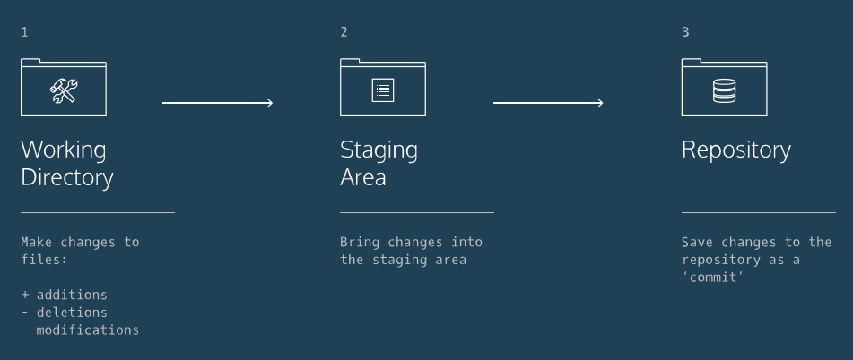
</ul>

<h2>Controlling Github Commits:</h2>
<ul>
- <li>Show most recent commit with ‘git show HEAD’</li>
- <li>restore file to previous commit version with ‘git checkout HEAD <filename>’</li>
- <li>remove files from staging area, if mistakenly added ‘git reset HEAD <filename>’</li>
- <li>reset WD to a previous commit with ‘git reset SHA’ where ‘SHA’ is the first 7 characters in the commit SHA you want.</li>
</ul>

<h2>Controlling Branches:</h2>
<ul>
- <li>Show which branch we are working in with ‘git branch’</li>
- <li>To create a new branch, use ‘git branch <new_branch>’</li>
- <li>To switch to a branch, use ‘git checkout <new_branch>’</li>
- <li>To merge a branch with another, navigate to host branch and use ‘git merge <branch_name>’</li>
- <li>To remove a branch, use ‘git branch -d branch_name’</li>
</ul>

<h2>Sharing Remotely:</h2>
<ul>
- <li>To clone an online repo, use ‘git clone <remote_location> <clone_name>’</li>
- <li>You can see a list of a Git project's remotes with the command: <git remote -v></li>
</ul>

